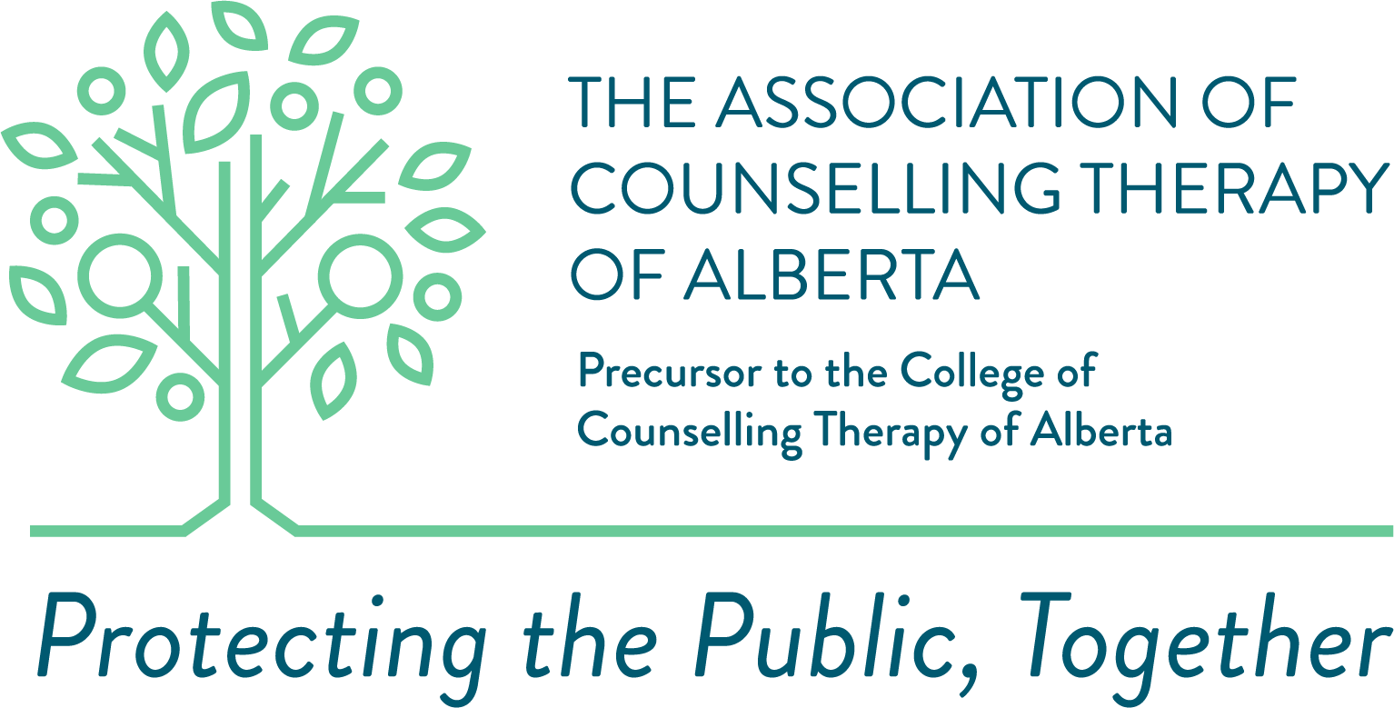

Procedure for Criminal Record and Vulnerable Sector Checks

Criminal Records checks must be dated less than one year from the submission date.

All applicants need to attend their local police detachment, whether in an urban or rural setting. Urban centers will go to police detachments (i.e. Calgary Police Service or Edmonton Police Services). Rural centres will go to the nearest RCMP detachment. Applicants must attend a detachment closest to their residence. ACTA has not registered, and there is no need for ACTA to register with any organization.

Process in Canada:

Step 1: Attend your nearest Police/RCMP detachment.
Step 2: Bring two pieces of government ID with you (one must be a photo ID).
Step 3: Request a Police check and a Vulnerable Sector check. Please indicate that it is
for a regulatory college, and the closest option would be employment.
Step 4: Have the police detachment mail the check back to you (the applicant).
Step 5: Pay the fee for having the check done.
Step 6: Once the form arrives, you must upload the document onto the Alinity system.

Things to Remember:

1. You will need to pay for the check to be done. The price will vary from region to region but can range between $40 and $80.
2. Bring two pieces of identification; one must be a photo ID.
3. You do NOT need a form from the Association, as we are not based in a specific
jurisdiction. You are completing the check on your own and will be providing the document to us once it is mailed or emailed back to you.

Process for International Applicants:

1. Vulnerable Sector Check from the country they are currently residing; and
2. Canadian Criminal Record Check, which can be completed online https://mybackcheck.com/Public/Login.aspx

